- Print/Copy/Scan
  - Your MIE department copy code is the last 4 digits of your GID#. You’ll need it at the Konika Minolta in the workroom. For your Grad Students/TA’s it is the last 5 digits of their GID#.
  - There are the two printers available for your use here at the M&IE office. To add a printer, use the addresses below. If our printers are busy (or broken) you are welcome to use the Dean’s Office copier in Roberts 212 – no copy code required.
  - Both copiers can print from a flash drive.

Workroom: Konica Minolta 754SeriesPCL (black and white, high capacity)
- At Windows Devices and Printers “Add a printer” “Network printer”
- At not found message enter using IP address IP_153.90.125.221
- At Printing Preferences
- Under the “Other” tab uncheck all of the boxes and click Apply.
- Under the “Basic” tab click on the Authentication/Account Track… button. In the Password enter the last four digits of your GID (employee/student ID number). Click Verify. Click OK. And then click OK again.
- Under the “My Tab” tab set the “Print Type” box to 1-Sided. Click Apply.
- If this does not work, you will need to see Dagny for the Zip Drive for driver software and instillation guide.
      - Double Click the KM 754SeriesPCL Folder
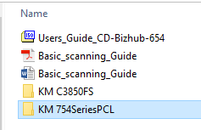
      - Double Click on Bizhub-654e

      - Double Click on Bizhub-654e
      - Copy the win7_x86zipfile and extract it to your computer.
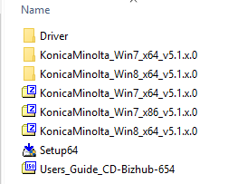

      - Double Click on the Driver Folder
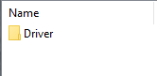

      - Run the Setup
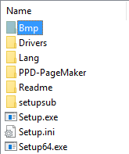

      - It should auto run and find the Konika Minolta 754 Series PCL (IP address 153.90.125.221)

      - Once Installed, open “Devices and Printers” from the start menu and right-click on the Konica and select Printing Preferences.
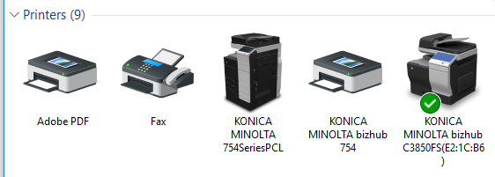
- Select ‘Printing Preferences:
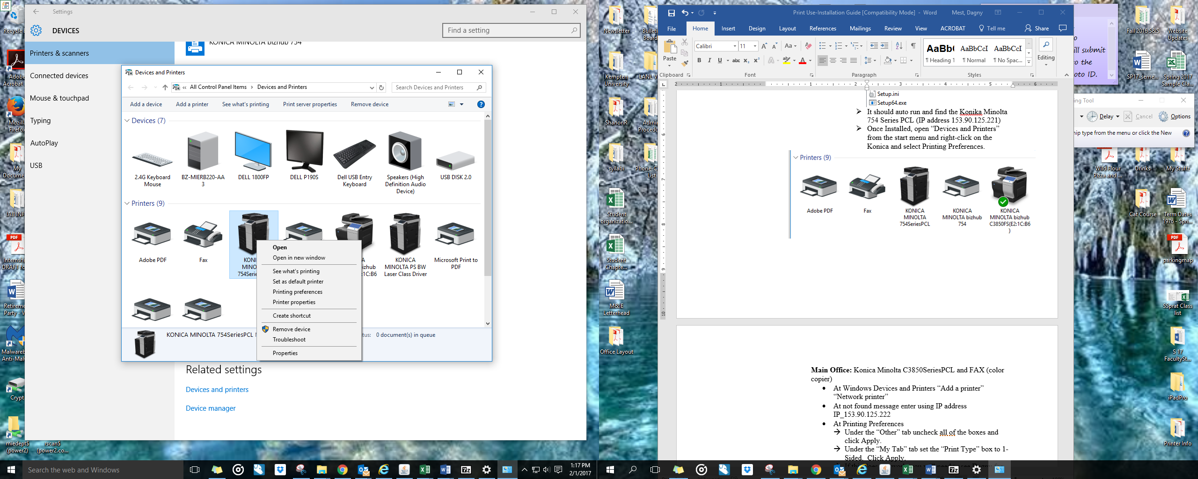

- Under the ‘Other’ tab, uncheck all the boxes:
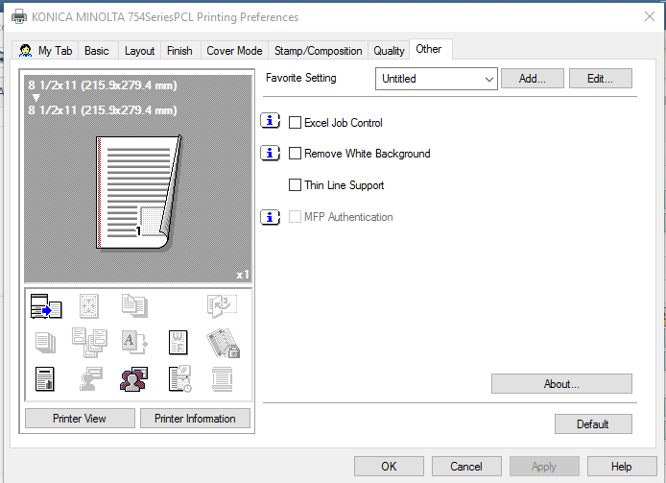

- Then click the ‘Apply’ button.
- Under the ‘Basic’ tab, click ‘Authentication/Account Tracking’,
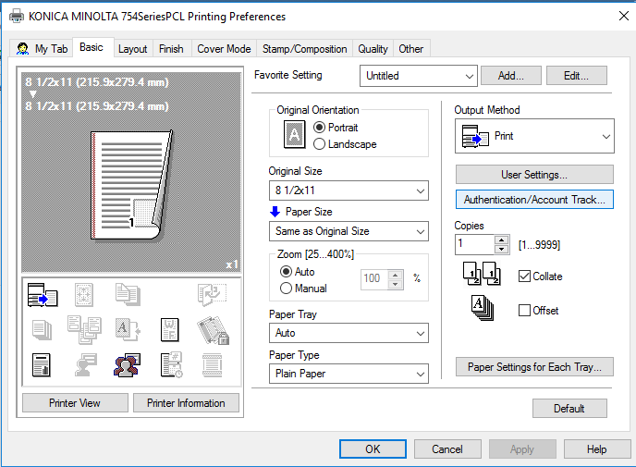
- Enter your PIN (the last 4 digits of your GID#) in the password box and then click verify:
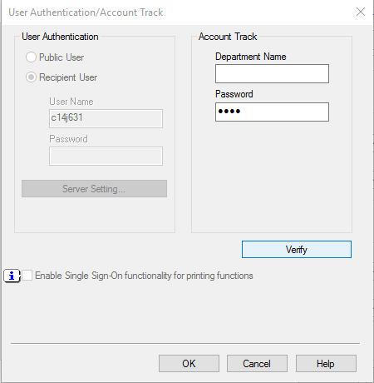

- Exit Out by clicking ‘OK’

- You’re all set and should be good to go for printing!

Main Office: Konica Minolta C3850SeriesPCL and FAX (color copier)
- At Windows Devices and Printers “Add a printer” “Network printer”
- At not found message enter using IP address IP_153.90.125.222
- At Printing Preferences
- Under the “Other” tab uncheck all of the boxes and click Apply.
- Under the “My Tab” tab set the “Print Type” box to 1-Sided. Click Apply.
- If this does not work, you will need to see Dagny for the Zip Drive for driver software and instillation guide.
      - Double Click the KM C3850FS Folder
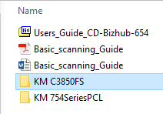
      - Double Click on Bizhub-C3850_MIEOffice folder
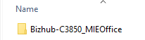
      - Double Click on either the ‘windows’ folder
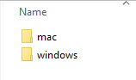
      - Copy the Drivers folder to your computer.
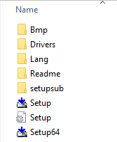
      - Double Click on the Setup; then Run the Setup
      - It should auto run and find the Konika Minolta bizhub C3850FS (IP address 153.90.125.222)

- Once Installed, you should be all set and good to go for printing!

